Creating Microservices for Account and Loan
1. Project Overview
- 1.1 Objective: To design and deploy two distinct, independent Spring Boot web applications (Account Service and Loan Service) that simulate a microservices architecture for a bank.
- 1.2 Use Case: Demonstrating how large monolithic applications can be split into smaller, domain-specific services that run simultaneously and independently on the same server environment.
2. Architecture & Setup
- 2.1 Shared Technology Stack: Both microservices are built using Java, Maven, Spring Web, and Spring Boot DevTools.
- 2.2 Project Isolation: Each microservice has its own root folder, its own pom.xml, its own embedded web server, and its own completely separate codebase. They do not share a database for this exercise (mock data is used).
3. Implementation: Account Microservice
- 3.1 Configuration: Runs on the default embedded Tomcat port (8080).
- 3.2 The Data Model (Account.java): Contains fields for number, type, and balance with an all-arguments constructor and standard getters/setters.
- 3.3 The Controller (AccountController.java):
  - Endpoint: Mapped via @GetMapping("/accounts/{number}").
  - Behavior: Captures the account number from the URL using @PathVariable and returns a hardcoded Account object serialized as JSON.
- 3.4 Sample Response:
JSON
{
"number": "00987987973432",
"type": "savings",
"balance": 234343
}
4. Implementation: Loan Microservice
- 4.1 Configuration (Port Conflict Resolution):
  - File: application.properties
  - Setting: server.port=8081
  - Reason: Overrides the default port to prevent a BindException (Address already in use) since the Account microservice occupies port 8080.
- 4.2 The Data Model (Loan.java): Contains fields for number, type, loan, emi, and tenure.
- 4.3 The Controller (LoanController.java):
  - Endpoint: Mapped via @GetMapping("/loans/{number}").
  - Behavior: Returns a hardcoded Loan object representing a car loan.
- 4.4 Sample Response:
JSON
{
"number": "H00987987972342",
"type": "car",
"loan": 400000,
"emi": 3258,
"tenure": 18
}
5. Execution and IDE Integration (SME Walkthrough)
- 5.1 Simultaneous Execution: Both the MicroservicesApplication and LoanMicroservicesApplication are executed concurrently from within the IDE.
- 5.2 Port Binding: The startup logs confirm successful initialization:
  - Account Service logs: Tomcat initialized with port 8080 (http)
  - Loan Service logs: Tomcat initialized with port 8081 (http)
- 5.3 IntelliJ IDEA Services Window:
  - When multiple Spring Boot applications run simultaneously, IntelliJ intelligently groups them into the Services tool window (Alt+8 / Cmd+8).
  - This UI provides a centralized dashboard to monitor the status of all active microservices, allowing the developer to seamlessly toggle between the individual console logs of the Account and Loan applications without losing context.

src/main/java/com/cognizant/account
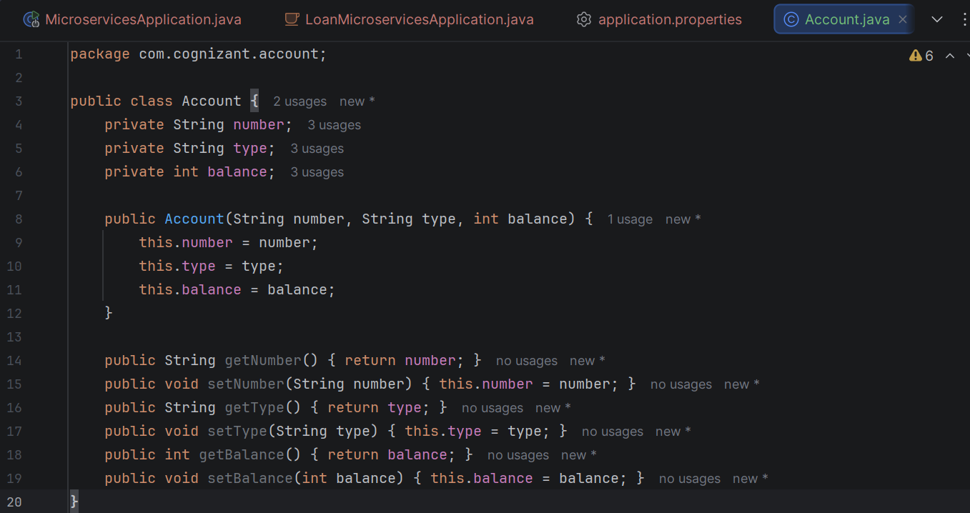

AccountController
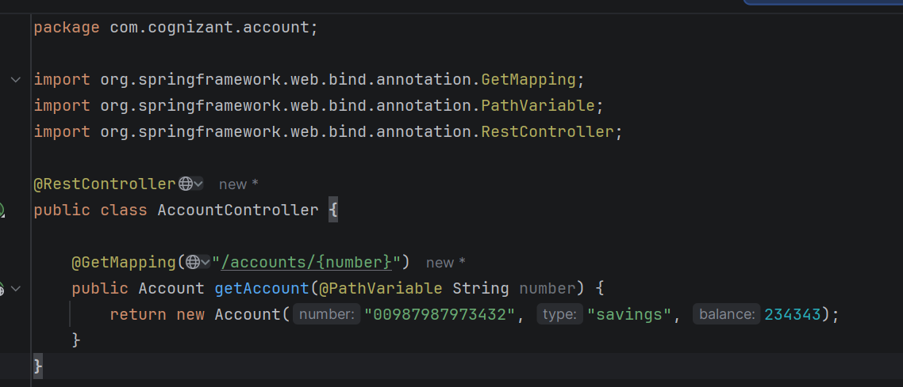

Execution Result:
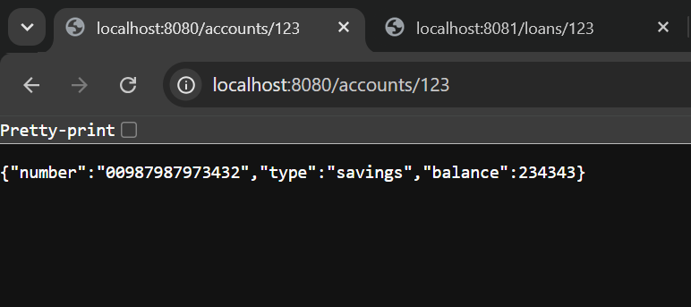

src/main/java/com/cognizant/loan
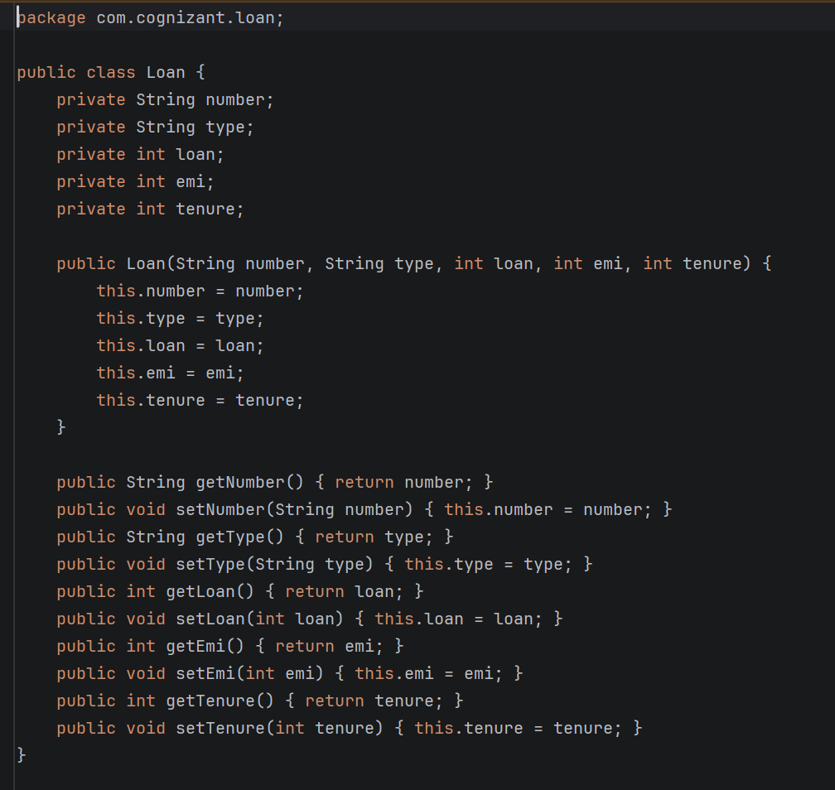

LoanController.
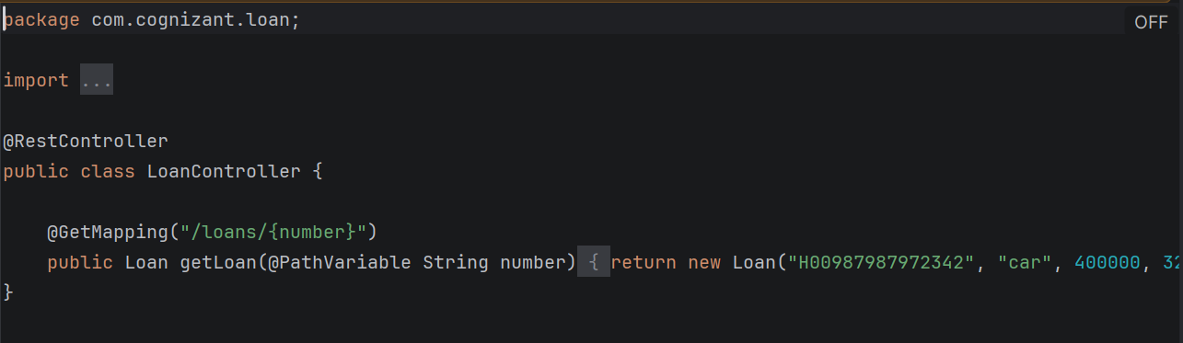
Execution Result :
